**WAREHOUSE MANAGEMENT**

**A PROJECT REPORT**

***Submitted by***

# Pansuriya Darshil Jaysukhbhai

**180840131033**

***In fulfilment for the award of the degree***

***of***

# BACHELOR OF ENGINEERING

### in

**Computer Science Engineering**

**R.N.G PATEL INSTITUTE OF TECHNOLOGY - RNGPIT**

**ISROLI (BARDOLI)**



# Gujarat Technological University, Ahmedabad

**April - May, 2022**





**R. N. G. Patel Institute of Technology, Bardoli – Navsari Road,**

**At: Isroli (Tajpore) PO: Afwa  
Tal: Bardoli – 394620**

**CERTIFICATE**

Date:

This is to certify that the Project report submitted along with the project entitled **Warehouse management** has been carried out by **Pansuriya Darshil Jaysukhbhai (180840131033)** for subject Internship (Subject Code:3180701) under my guidance in fulfilment of the degree of Bachelor of Engineering in Computer (8th Semester) of Gujarat Technological University, Ahmadabad during the academic year 2021-22.

Mr. Vivek C. Joshi Dr. Madhavi B. Desai

Internal Guide Head of the Department

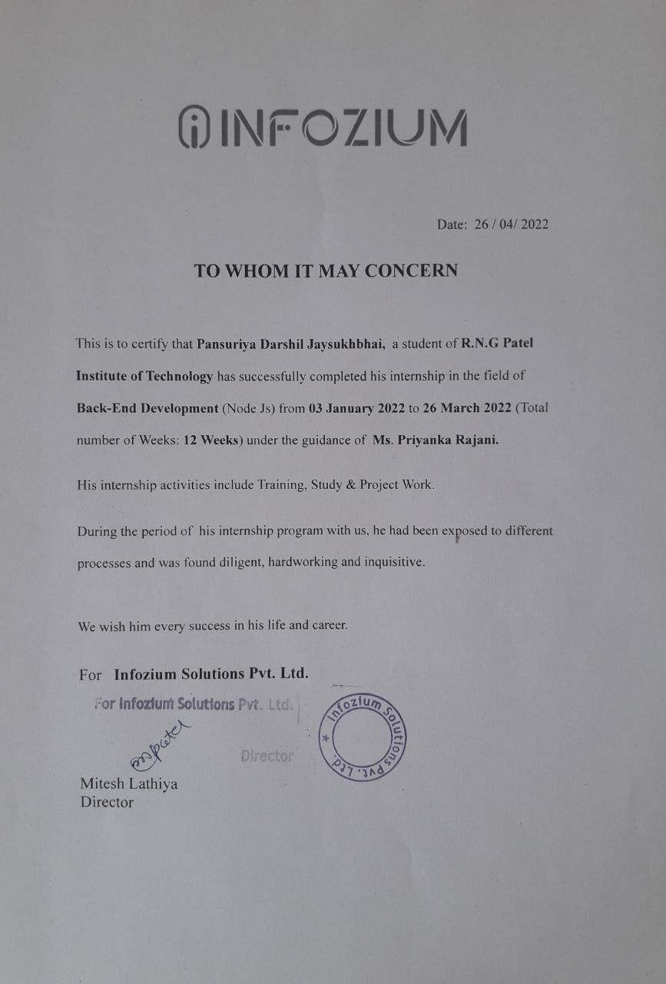

 

**R. N. G. Patel Institute of Technology, Bardoli – Navsari Road,**

**At: Isroli (Tajpore) PO: Afwa  
Tal: Bardoli – 394620**

**DECLARATION**

We hereby declare that the Internship report submitted along with the Project entitled **Warehouse Management** submitted in partial fulfilment for the degree of Bachelor of Engineering in Computer Science to Gujarat Technological University, Ahmedabad, is a bonafide record of original project work carried out by me at **R. N. G. Patel Institute Of Technology** under the supervision of **Mr. Vivek C. Joshi** and that no part of this report has been directly copied from any students’ reports or taken from any other source, without providing due reference.

Name of the Student Sign of Student

Pansuriya Darshil Jaysukhbhai ______________________

**ACKNOWLEDGEMENT**

The satisfaction that accompanies the successful completion of this internship would be incomplete without mentioning the people who made it possible, without whose constant guidance and encouragement would have made efforts go in vain. I consider myself privileged to express gratitude and respect towards all those who has guided through the completion of projects.

I extend my deepest gratitude to my mentor **Mr. Vivek C. Joshi** for guiding, supporting and helping me in every possible way.

During my internship, My supervisor **Ms. Priyanka Rajani** from Infozium Solution PVT. LTD. was very helpful and extended his valuable guidance and provide help whenever required.

I am grateful to **Dr. Madhavi Desai**, Head of the Department, Computer Science & Engineering, RNGPIT for giving us the support and encouragement that was necessary for the completion of this internship.

I would also like to express my deepest gratitude to **Dr. Latesh Chaudhari**, Principal of R. N. G. Patel Institute of Technology for providing us congenial environment to work in.

I would also like to thank Placement Cell of the department for giving me an opportunity to be the part of this internship. I extend my gratitude to all the faculty members for their understanding and guidance that gave me strength to work to long hours for developing a project and preparing the report.

**Pansuriya Darshil Jaysukhbhai (180840131033)**

**Abstract**

Warehouse Management is based upon delivery services of orders. It has mainly three Roles are Admin, Warehouse Manager and Delivery Boy In which admin and warehouse manager uses the web app and delivery boy uses the mobile app. Admin can add/edit/delete Warehouse Manager and Delivery Boy as well apart from that admin can view/ edit delivery boy and Warehouse Manager. Admin can Manage, view, Assign Orders to Managers and Delivery Boys.

Warehouse Manager assign order to Delivery Boy and Download status of order and Payment Collection report. Delivery Boy view all orders and Delivered the order and update the status of order and collect the payment.

**List of Figures**

Fig 1.6.1 Organization Chart .............................................................................................. 10

Fig 5.1 Use case Diagram .................................................................................................. 10

Fig 5.2 Activity Diagram .................................................................................................. 11

Fig 6.3.1 Folder structure of Project …….......................................................................... 13

Fig 6.3.2 Admin create manager and delivery person........................................................ 13

Fig 6.3.3 Admin can block Manager ................................................................................. 14

Fig 6.3.4 Admin view list of all manager………................................................................ 14

Fig 6.3.5 Manager can not login…………………............................................................. 15

Fig 6.3.6 Upload excel file…………………...................................................................... 15

Fig 6.3.7 Manager assign Order………………................................................................. 16

Fig 6.3.8 Order of Delivery Person……………................................................................. 16

Fig 6.3.9 Update the Status of Order……….……............................................................. 17

Fig 6.3.10 Delivery person wise order……....................................................................... 17

Fig 6.3.11 History of orders for delivery person……….................................................... 18

Fig 6.3.12 Cash collection of delivery person………….................................................... 18

Fig 6.3.13 Database…………………………………….................................................... 19

Fig 6.3.14 View Reports……………………………….................................................... 19

Fig 6.3.15 Project Code-1……………………………….................................................. 20

Fig 6.3.16 Project Code-2…………………...................................................................... 20

Fig 7.2.1.1 Test Case-1……………………...................................................................... 20

Fig 7.2.2.1 Test Case-1……………………...................................................................... 20

Fig 7.2.3.1 Test Case-1……………………...................................................................... 20

**List of Tables**

Table 3.7.1 During January ............................................................................................. 33

Table 3.7.2 During February ........................................................................................... 34

Table 3.7.3 During March ............................................................................................... 34

Table 5.3.1 Sale Table …................................................................................................. 34

Table 3.7.3 Warehouse Table .......................................................................................... 34

Table 3.7.3 Manager Table.............................................................................................. 34

Table 3.7.3 Delivery Person Table .................................................................................. 34

**Abbreviations**

UI User Interface

QA Quality Assurance

API Application Programming Interface

JS Javascript

**Table of Contents**

Acknowledgment............................................................................................................... i

Abstract.............................................................................................................................. ii

List of Figures.................................................................................................................... iii

List of Tables ..................................................................................................................... v

List of Abbreviations ........................................................................................................ vi

Table of Contents.............................................................................................................. vii

**Chapter 1 Overview of the Company............................................................................. 1**

1.1 History of the Company.............................................................................................. 1

1.2 Scope of work………………………………………….…………………………… 1

1.3 More About Company’s Information…………………..………………………....... 2

1.4 Company Vision…………………...………………………….………………......... 2

1.5 Company Objective …………………………………..………………………......... 2

1.6 Organization Chart .…………………………………..………………………......... 2

**Chapter 2 Overview of different department of the organization and Layout of the Production/process being carried out in company**......................................................... 3

2.1 Departments ………………………………………………………………............... 3

2.1.1 Mobile Application Department........................................................................... 4

2.1.2 Web Application Department............................................................................... 4

2.1.3 Game Department………..................................................................................... 4

2.2 Steps to complete a project…………………………………………………............. 3

2.3 Sequence of operation ….……………………………………………....….............. 3

**Chapter 3 Introduction to Internship and Project……..……………………….…….. 4**

3.1 Internship Summary ................................................................................................... 4

3.2 Purpose Of Internship……...…………………………..…………………...……..... 4

3.3 Objective Of Internship……………...……………………………..………..……… 5

3.4 Scope Of Internship…...…………………………………………………………..... 5

3.5 Technology and Literature review ……………………………………..……..……. 5

3.5.1 Node JS …..……………………………………………………..………...……. 5

3.5.2 MySQl…..………………………………………………………………...…..... 6

3.6 Internship Planning …………………………………………………………..…...... 7

3.6.1 Project Development Approach ………………………………………..……..... 7

3.6.2 Roles & Responsibilities ……………………………………………….……..... 7

3.7 Internship and Project scheduling ………………………………………..…………. 7

**Chapter 4 System Analysis** …………………………………………………………....... 8

4.1 Case Study of current system……………………………………………………….. 8

4.2 Problems of current system ……………………………………………………..….. 8

4.3 Requirement of new system ……………………………………………………….. 8

4.4 System Feasibility …….……………………………………………………………. 8

4.5 Features of System ….…..………………………………………………………….. 9

4.6 Main Modules …………...……………….………………………………………..... 9

4.7 Selection of software and hardware ……...………………………………………..... 9

**Chapter 5 System Design ……………………………………………………………… 10**

5.1 Use case Diagram ………………………………………………………………..... 10

5.2 Activity Diagram ………………………………………………………………….. 11

5.2 Database Design .………………………………………………………………….. 11

**Chapter 6 Implementation …………………………………………………………….. 12**

6.1 Implementation Platform ………………………………………..………………… 12

6.2 Module Specification …………………………………………………………........ 12

6.2.1 Admin Manages Manager and Delivery Person ……………………..…..……. 12

6.2.2 Manager can Upload Order and assign .………………………………………. 12

6.2.3 Admin and Manager can view reports of order…..……………………………. 12

6.3 Snapshots ...…………………………………………………………………........... 13

**Chapter 7 Testing …………………………………………………………………........ 33**

7.1 Testing Plan ...…………………………………………………………………....... 33

7.2 Test Result and Analysis ………………………………………………………....... 33

7.2.1 Test Case-1 …..……………………………………………..………...…... 35

7.2.2 Test Case-2 …..……………………………………………..………...…... 35

7.2.3 Test Case-3 …..……………………………………………..………...…... 35

**Chapter 8 Conclusion & Discussion……………………………………………...……. 35**

8.1 Overall Analysis of Internship …...…………………………………………...…… 35

8.1 Date of Surprise visit by institute mentor……………………………………...…… 35

8.3 Dates of Continuous Evaluation……………………………………………..…….. 35

8.4 Problems encountered and possible solution …….……………………….....…….. 35

8.5 Internship summary ……………………………………………………………….. 35

8.6 Limitations and Future Enhancement ………………………………………........... 36

References.......................................................................................................................... 38

**Chapter: 1 OVERVIEW OF THE COMPANY**

* 1. **History**

Started Since 2011, our Co-Founder Mr. Mitesh Lathiya left his high-paying job and took a risk & loan of 2 lakh Rupees to launch the Start-Up called Infinity, an I.T. services provider for few selected Indian & International clients. In 2014 Initial development & exposure stage provided the team enthusiasm & credibility to develop their own products and rename Infinity as PistaLix!. In 2017 With additional convenience, vital technical assistance, and comprehensive services, we have succeeded and decided to change the Pistalix solution to InFoZium.

* 1. **SCOPE OF WORK**

Company have mainly 3 teams and first is Infizius which is provide mobile application service over the world wide and second is Xtripo travel which is companies own product it’s basically ERP for business and third is Playmax gaming which is provides gaming solution and create multiple games delivery to clients. Apart from these company is working on more own products for mobile and web.

**1.3 More About Company’s Information**

The Infozium Group has established itself as one of the most sought-after technology partners in a variety of industries, especially in the context of digital transformation. By offering the best in our field, we have extended our Infozium Group in 3 different areas. We have a long-standing client who has been with us for many years, and our success is shown in our consistent and steady expansion of firms.

Achievements of Company :-

* Xtripo achieved IATA certification and Startupindia certification, a remarkable success within small time.
* Certificate of Accreditation By Infozium Solution PVT LTD.

**1.4** **Company Vision**

Creating young Zinius for delivering futuristic growth with infinite technology services & solutions. The Infozium Group is to achieve our group revenue of 1000 crores and group net valuation of 5000 crores by 2025 through supporting our clients with technical services & solutions beyond their expectations.

**1.5 Company Objective**

Clear standards and trust-based relationships are important to us since they enable us to enhance delighted customers and employees. By continues, collaboration with the customer helps us to deliver innovative & customer-centric solutions on time. Always Make Client happy with Satisfactory project delivery and give some extra benefits over the delivery of product make client more happy and growth the company revenue and market. Working on more companies products which are solve the B2B Business problems with create multiple platform application and website.

**1.6 Organization Chart**

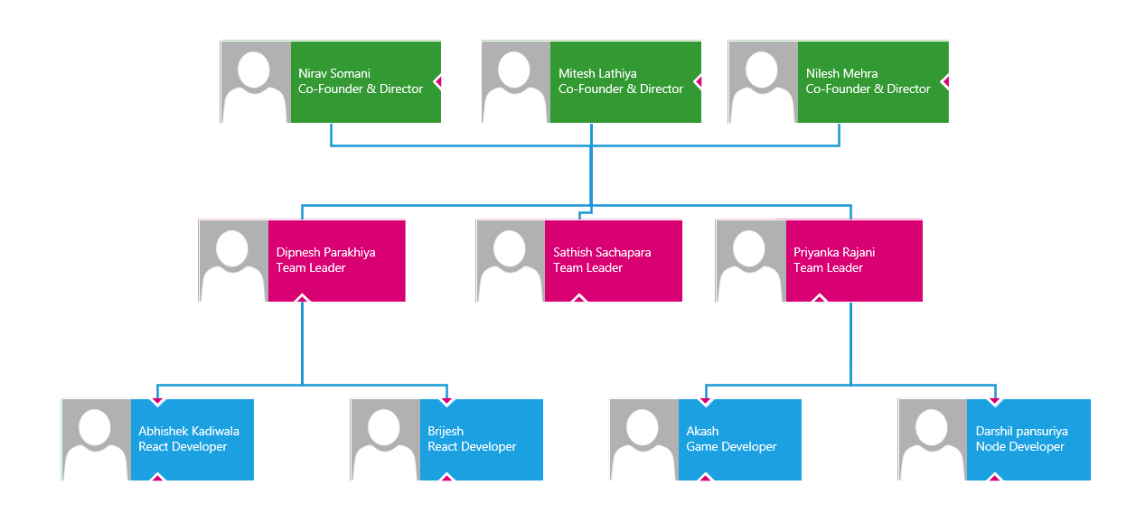

Fig 1.6.1 Organization Chart

**CHAPTER:2 OVERVIEW OF DIFFERENT DEPARTMENT OF THE ORGANIZATION AND LAYOUT OF THE PRODUCTION/PROCESS BEING CARRIED OUT IN COMPANY**

**2.1 Departments**

At our company there are Many departments.

* Mobile Application Department - Infizius Team
* Web Applications Department - Xtripo Travel Team
* Gaming Department - Playmax Gaming Team
* Marketing Team – BDM Team

**2.1.1 Mobile Application Department**

We provide a comprehensive solution and everything you need to develop your own mobile app (Android & iOS) without any coding knowledge! Infizius has extensive experience developing high-performing, digitally transformational, and feature-rich mobile apps for all major mobile platforms. It doesn’t matter if it’s an Apple, Android, or hybrid device. We have digital Einstein developers who can construct dynamic, high-quality mobile apps for a variety of platforms. All you have to do now is pick from our collection of high-quality, ready-to-use web & app templates and let our team of experts handle the rest.

**2.1.2 Web Applications Department**

Xtripo has revolutionized the travel industry. We tailor end-to-end travel services, such as selecting and arranging acceptable flights before moving on to hotel stays. We have dominant hotel affiliations all over the world, allowing us to give the best value for our customers’ money. We have a skilled team that will respond to your questions as quickly as possible. Our staff will research the greatest vacation packages available, sort through cruise packages, and complete your entire trip in one go.

**2.1.3 Game Department**

Playmax Gaming is one of the world’s fastest-growing game development company. As a leading game design and development firm, Playmax can be your one-stop shop for all of your game development needs. Among the services we provide are conception enhancement, character customization, graphics and animation, game mechanics, coding, and testing.

**2.2 Steps to Complete a Project**

Most of the time company is using Automatic scanning tools for the small size of the project, but when the project is at large scale, company use agile methodology. Company is mainly focus on the deadline achievement. Our first priority when a project is assigned is that to complete the task in a given time and weeks.

**2.3 Sequence of Operation**

Requirement analysis is the most important and fundamental stage in Application Testing. It is performed by the senior members of the team with inputs from the hackers, the sales department, market surveys and domain experts in the industry. This information is then used to plan the basic project approach and to conduct product feasibility study in the economical, operational and technical areas.

Planning for the quality assurance requirements and identification of the risks associated with the project is also done in the planning stage.

After successfully complete security testing face they generate report bas on application testing. Send that report to that client and explain about web applications weakness and it’s bad impact. The outcome of the technical feasibility study is to define the various technical approaches that can be followed to implement the project successfully with minimum risks.

**Chapter: 3 INTRODUCTION TO INTERNSHIP AND PROJECT**

The internship program is designed to provide students engaged in a field experience with an opportunity to share their insights, to explore the links between students' academic preparation and their field work, and to assist participants in developing and carrying out the major research project which will serve to culminate their internship experience.

Internships are individualized and tailored to the needs and interests of each student in the program. As part of the internship experience, students are expected to take an active role in finding an appropriate internship for themselves. Many students pursue their own contacts, however, information is available on Locating Internship Sites.

**3.1 Internship Summary**

To experience the practical working of what we studied in the book theories, is very interesting, memorable and very important in our education. Doing internship is my first experience of working for any company and learn how the things are being done in the actual industry. It was very memorable and everlasting experience of doing an internship. I have done internship in Evolution info secure, Surat. It was 12 weeks long.

My Internship was excellent with full of hands on Experience. Learning a lot from the leader and company work culture how to deal with client and how to structure project. In Starting weeks Learning Node Js course from Udemy. Create Multiple APIs in Nodejs for learning purpose and worked on the warehouse management project. Overall Experience was Good learn and solve a lot’s from Real world problem and Projects solution.

**3.2 Purpose of Internship**

* Main Purpose of an Internship that I wanted to learn new technologies which are use by the companies Nowadays and the real or hands on work within the company and team.
* Internship is good things though which a we can see how Actual or Real work done in companies and what are client requirement and how to deal with them it’s a good experience that I want to pursue during Internship Period.
* My believe that Internship or Training and learn from Expert make growth success and under the work in senior developer will teach us to solving any kind of project and solution of any problem that I want to learn from Internship.

**3.3 Objective Of Internship**

* Apply skill concepts and theories to real-world decision-making
* Increase knowledge in are such as operations management, Website design and development, provide creative solution to client.
* Develop and improve skills in communication, technology, quantitative reasoning, and teamwork.
* Observe and participate in operations and decision-making will make confidence and Interest.
* Meet professional role models and potential mentors who can provide guidance, feedback, and support.
* Expand network of professional relationships and contacts.

**3.4 Scope of Internship**

* Gain knowledge from Internship and Industry Experts.
* An Internship Provides Real Life Experience and Exposure.
* Deal with Clients and find Solution of any project
* Get Connected and Develop Your Professional Network
* The Opportunity To Learn More About Yourself

**3.5** **TECHNOLOGY AND LITERATURE REVIEW**

**3.5.1 Node JS**

Features of Node.js:

Following are some of the important features that make Node.js the first choice of software architects.

* Asynchronous and Event Driven − All APIs of Node.js library is asynchronous, that is, non-blocking. It essentially means a Node.js based server never waits for an API to return data. The server moves to the next API after calling it and a notification mechanism of Events of Node.js helps the server to get a response from the previous API call.
* Very Fast − Being built on Google Chrome's V8 JavaScript Engine, Node.js library is very fast in code execution.
* Single Threaded but Highly Scalable − Node.js uses a single threaded model with event looping. Event mechanism helps the server to respond in a non-blocking way and makes the server highly scalable as opposed to traditional servers which create limited threads to handle requests. Node.js uses a single threaded program and the same program can provide service to a much larger number of requests than traditional servers like Apache HTTP Server [1].

**3.5.2 MySQL**

* MySQL is an open-source relational database management system. As with other relational databases, MySQL stores data in tables made up of rows and columns. Users can define, manipulate, control, and query data using Structured Query Language, more commonly known as [SQL](https://www.digitalocean.com/community/tutorials/what-is-sql)[3]. It is used wisely in software development, Web application development and mobile application etc.

**3.6 INTERNSHIP PLANNING**

**3.6.1 PROJECT DEVELOPMENT APPROACH**

Agile Software Development is highly encouraged and followed for the development of all types of Products. This is because of the flexibility and low cost and fast delivery that it offers. For this project, we have selected to go Agile software development.

The Reason for selecting Agile Software development is that it will give us the flexibility to make changes as per client requests throughout the project at any time. It will also help to keep the development cost low after several changes also throughout the project.

**3.6.2 ROLES & RESPONSIBILITIES**

Roles: Trainee Back-End Developer

Responsibilities:

* Learn Node JS and practicing of different types of APIs [1].
* Build the APIs for the warehouse management project.
* Working with source code management using GIT, GITHUB, GITLAB.

**3.7 INTERNSHIP SCHEDULING**

Table 3.7.1 During January

|  |  |  |  |  |
| --- | --- | --- | --- | --- |
|  | Week-1 | Week-2 | Week-3 | Week-4 |
| Introduction of Company and Node JS |  |  |  |  |
| Node JS Training |  |  |  |  |
| Node JS Training and Implement Some Demo Tasks |  |  |  |  |
| Node JS and MySQL Training |  |  |  |  |

Table 3.7.2 During February

|  |  |  |  |  |
| --- | --- | --- | --- | --- |
|  | Week-1 | Week-2 | Week-3 | Week-4 |
| Research and started planning of warehouse project. |  |  |  |  |
| Starting Implementation of Warehouse Management project |  |  |  |  |
| Implement APIs on manager, Delivery person |  |  |  |  |

Table 3.7.3 During March

|  |  |  |  |  |
| --- | --- | --- | --- | --- |
|  | Week-1 | Week-2 | Week-3 | Week-4 |
| Implement APIs on Order in Warehouse Project |  |  |  |  |
| Implement Report APIs in Warehouse  Project |  |  |  |  |
| Started Working on battleship game project |  |  |  |  |
| Build APIs on battleship game project |  |  |  |  |

**Chapter 4: SYSTEM ANALYSIS**

**4.1 STUDY OF CURRENT SYSTEM**

Currently, the system is in development phase. The E-Commerce web application is developed and in next phase to develop a system for the delivery of orders.

The E-Commerce web application already developed by the client and our work is to design a system for the delivery of placed orders and manages the warehouses.

**4.2 PROBLEM OF CURRENT SYSTEM**

We developed the warehouse management system which resolved the delivery services of placed orders.

**4.3 REQUIREMENT OF NEW SYSTEM**

Warehouse Management system used for the manages the warehouses. Admin can create warehouse, warehouse manager, delivery person and also edit, block the delivery person and manager. Warehouse manager can upload the excel file and get the all its orders and assign orders to delivery person. Delivery person view its orders and delivered order then update status of delivery and if payment type is cash on delivery then collect the payment. Manager can view the cash collection report of all delivery boy and take the collection.

**4.4 SYSTEM FEASIBILITY**

This system implemented using the currently available technologies and within the schedule constraints. System can be integrated with other system which already in placed. System build with latest technologies i.e. NodeJS, ReactJS, Flutter etc.

**4.5 FEATURES OF SYSTEM**

* Security features of web application and mobile is Login for the user.
* List of Warehouses.
* List of Warehouse Manager and Delivery Person.
* Edit, block the Manager and Delivery Person.
* Track delivery status of order.
* Orders history.
* Payment history.

**4.6 Main Modules**

**Admin**

* Create, Edit, Block-Unblock manager and delivery person.
* Create Warehouses.
* List of Warehouses, Managers and Delivery persons.
* View the reports of Order.

**Manager**

* Upload the Order.
* Order assign to delivery persons.
* Check the status of delivery of orders.
* Report of orders datewise.

**Delivery Person**

* View its Orders for delivery.
* Delivered Order and update status.
* Payment collection.
* History of Delivered Orders.

**4.7** **SELECTION OF SOFTWARE AND HARDWARE**

**Selection of Software**

* Visual Studio Code
* MySQL Workbench
* Postman
* Nodejs
* MySQL

**Selection of Hardware**

* Processor: x64-based processor
* RAM: Minimum 4 GB

**CHAPTER 5: SYSTEM DESIGN**

**5.1 Usecase Diagram**

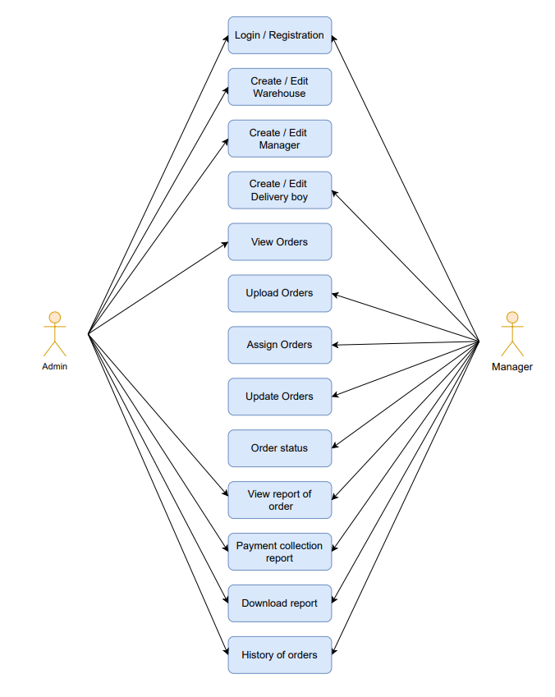

Fig 5.1 Use case Diagram

**5.2 Activity Diagram**

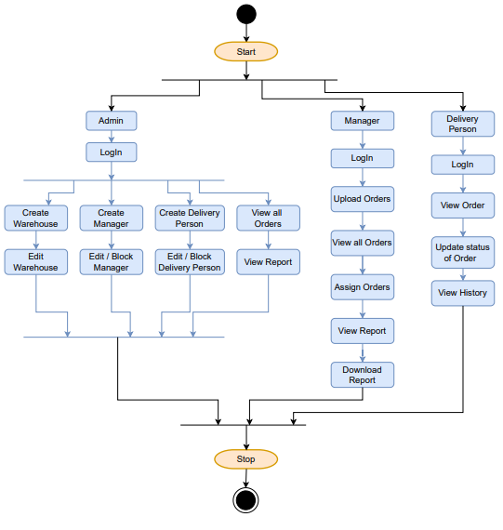

Fig 5.2 Activity Diagram

**5.3 Database Design**

Table 5.3.1 Sale Table

|  |  |  |  |  |
| --- | --- | --- | --- | --- |
| **Column Name** | **Data Type** | **Size** | **Constraint** | **Description** |
| sale_id | INT | N/A | Primary Key | Sale Id |
| order_id | VARCHAR | 20 | --- | Order Id |
| payment_type | ENUM | 20 | --- | Payment Type |
| grand_total | FLOAT | 10 | --- | Payment Amount |
| shipping_address | VARCHAR | 200 | --- | Shipping Address |
| awb_code | INT | N/A | --- | AWB Number |
| delivery_person_id | INT | N/A | --- | Delivery Person Id |
| manager_id | INT | N/A | --- | Manager Id |
| assign | BOOLEAN | N/A |  | Order assign or not |
| assign_date | DATE | N/A | --- | Order assign date |
| delivery_type | ENUM | N/A | --- | Delivery Type |
| delivery_status | ENUM | N/A | --- | Delivery Status |
| delivered_date | DATE | N/A | --- | Delivered Date |
| comments | VARCHAR | 100 | --- | Comments |

|  |  |  |  |  |
| --- | --- | --- | --- | --- |
| **Column Name** | **Data Type** | **Size** | **Constraint** | **Description** |
| warehouse_id | INT | N/A | Primary Key | Warehouse Id |
| warehouse_name | VARCHAR | 20 | --- | Warehouse Name |
| warehouse_location | VACHAR | 20 | --- | Warehouse Location |

Table 5.3.2 Warehouse Table

Table 5.3.3 Manager Table

|  |  |  |  |  |
| --- | --- | --- | --- | --- |
| **Column Name** | **Data Type** | **Size** | **Constraint** | **Description** |
| manager_id | INT | N/A | Primary Key | Warehouse Manager Id |
| name | VARCHAR | 20 | --- | Warehouse Manager Name |
| location | VARCHAR | 20 | --- | Warehouse Manager Location |
| email | VARCHAR | 20 | --- | Warehouse Manager Email |
| password | VARCHAR | 20 | --- | Warehouse Manager Password |
| Is_Active | BOOLEAN | N/A | --- | Active Or Not |
| warehouse_id | INT | N/A | Foreign Key | Warehouse Id |

Table 5.3.4 Delivery Person Table

|  |  |  |  |  |
| --- | --- | --- | --- | --- |
| **Column Name** | **Data Type** | **Size** | **Constraint** | **Description** |
| del_person_id | INT | N/A | Primary Key | Delivery Person Id |
| name | VARCHAR | 20 | --- | Delivery Person Name |
| location | VARCHAR | 20 | --- | Delivery Person Location |
| email | VARCHAR | 20 | --- | Delivery Person Email |
| password | VARCHAR | 20 | --- | Delivery Person Password |
| Is_Active | BOOLEAN | N/A | --- | Active Or Not |
| manager_id | INT | N/A | Foreign Key | Manager Id |

**CHAPTER 6: IMPLEMENTATION**

**6.1 IMPLEMENTATION PLATFORM**

This project is a web app-based systems so the following tools is used to develop the proposed application.

Tools and Platforms used to implement are:

* Visual Studio Code
* MySQL Workbench
* Postman

**6.2 MODULE SPECIFICATION**

I have been assigned to the following modules in this project:

**6.2.1 Admin Manages Warehouse Manager and Delivery Person**

In this module I’ve developed APIs for Create, Edit, Block the Warehouse, Warehouse Manager, Delivery Person.

**6.2.2 Manager can upload order and assign order**

In this module I’ve developed APIs for manager can upload orders, view all orders, view assign orders, delivery type of orders, assign orders to delivery person.

**6.2.3 Admin and Manager can view reports of orders**

In this module, I’ve added APIs for manager and admin can check the status of order by particular Delivery person and the from and to Date and also download the payment collection report.

**6.3 Snapshots**

* Folder structure of the Project

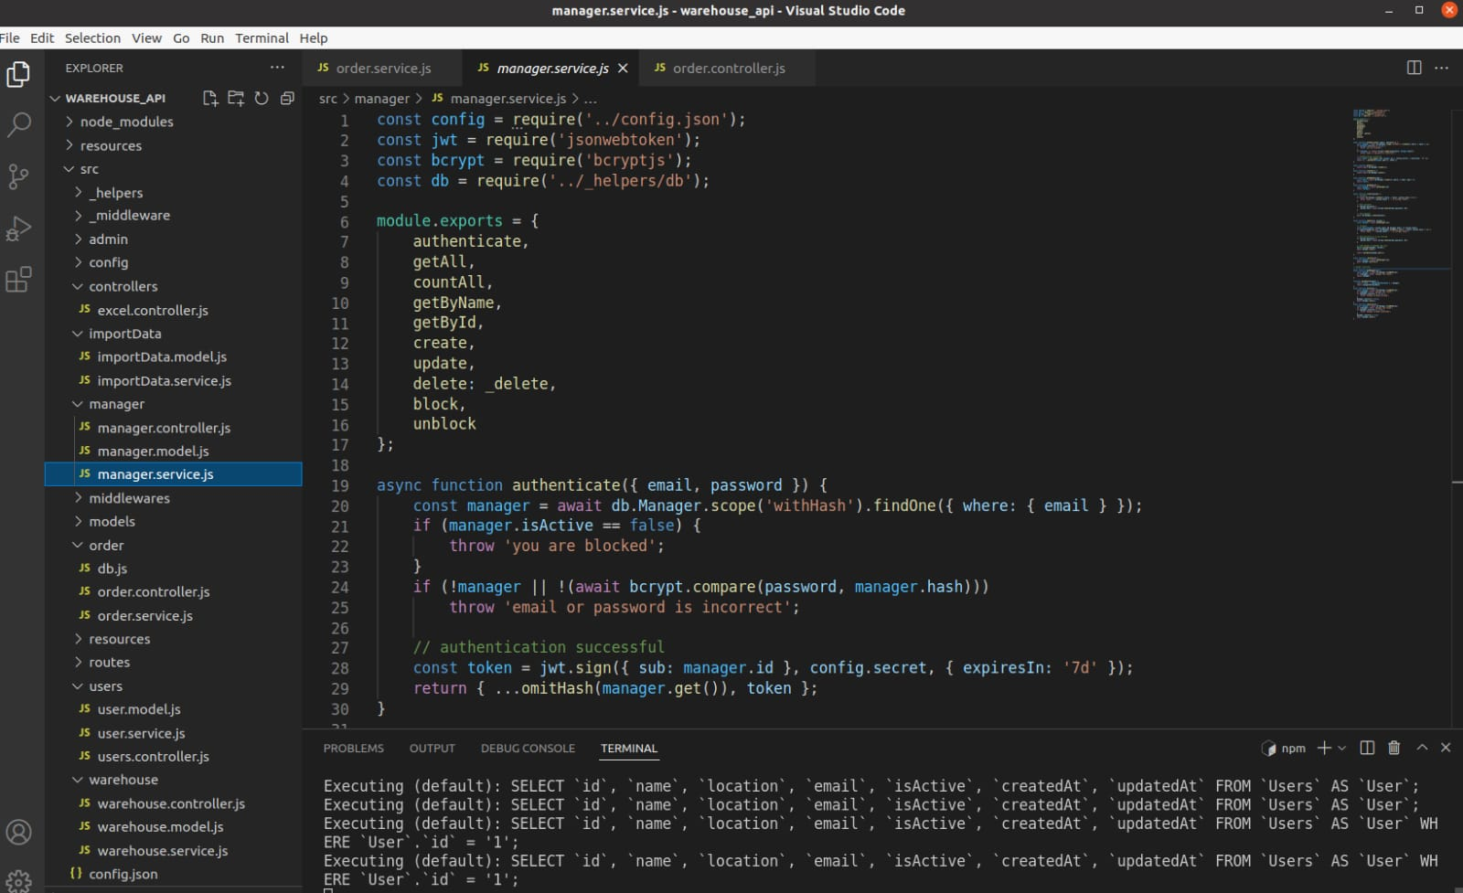

Fig 6.3.1 Folder structure of Project

* API of the admin can create manager and delivery person.

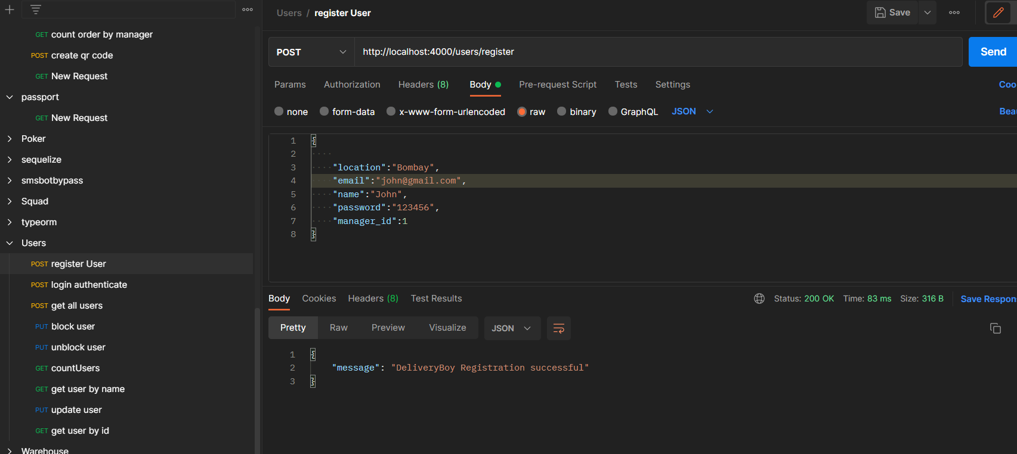

Fig 6.3.2 Admin create manager and delivery boy

* Admin can edit, block-unblock manager and the delivery person.

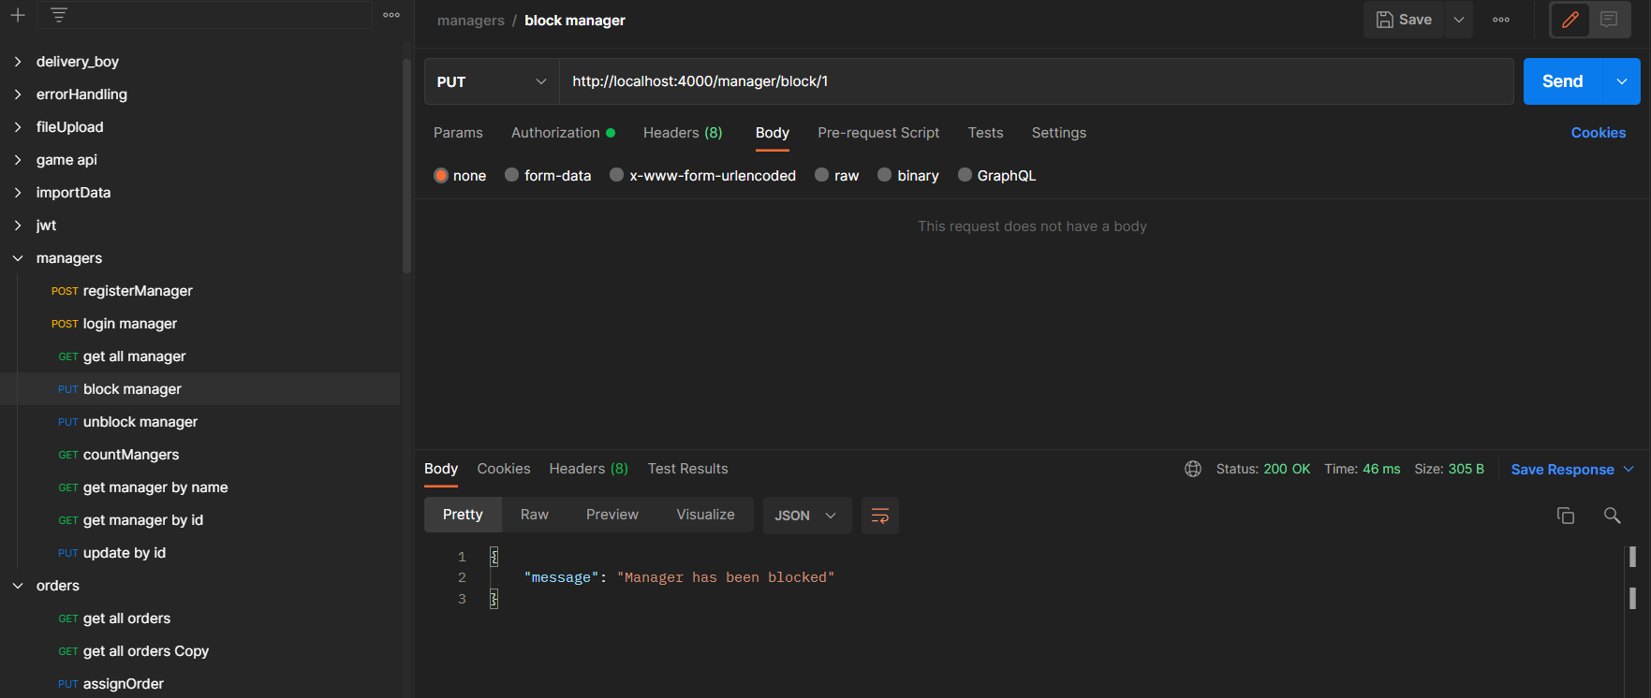

Fig 6.3.3 Admin block manager

* Admin can view list of all manager, delivery person and warehouses.

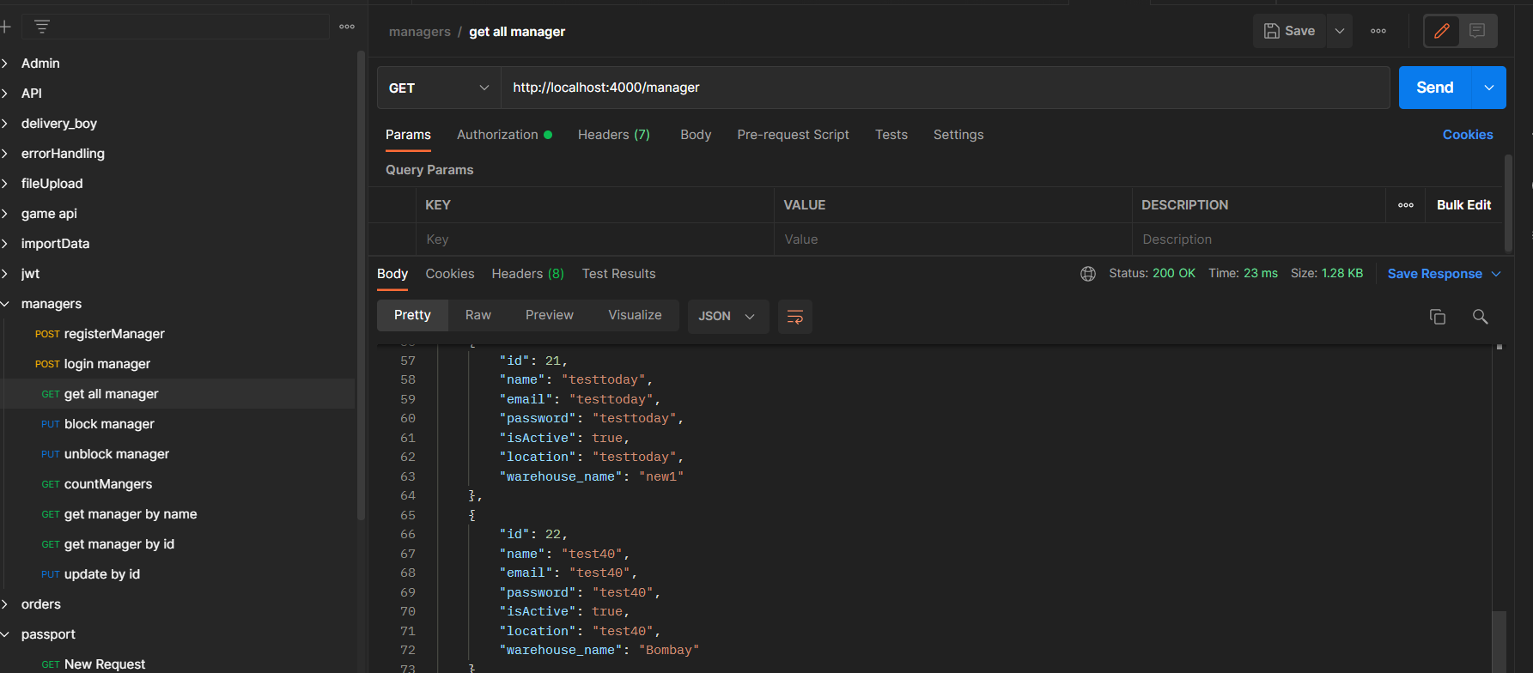

Fig 6.3.4 Admin view list of all managers

* If manager or delivery person are blocked by admin than they can not login.

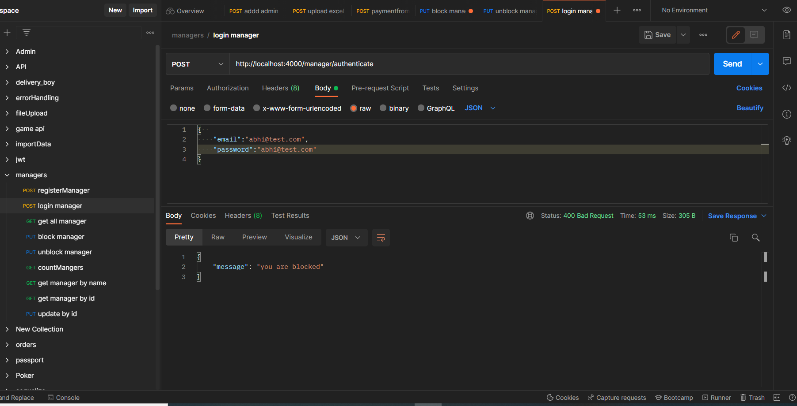

Fig 6.3.5 Manager can not login

* If manager can upload file except the excel file it gives the error. [4]

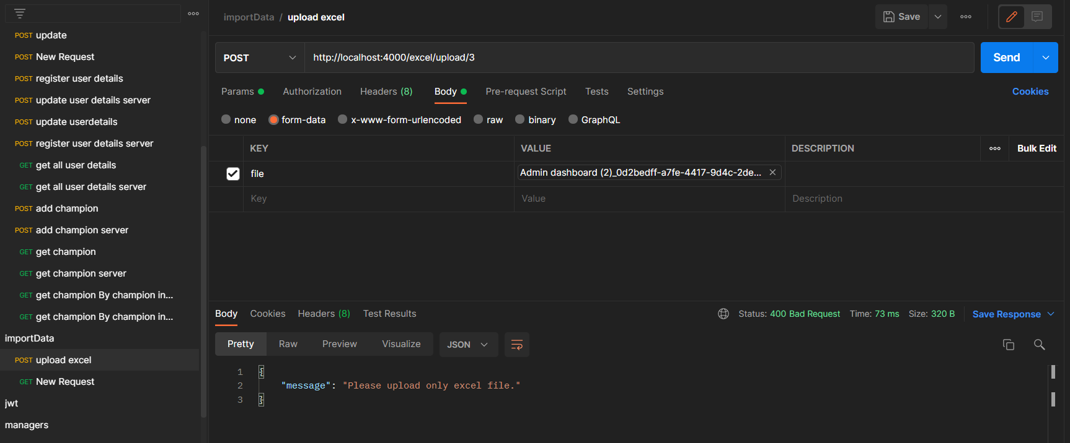

Fig 6.3.6 Upload excel file

* Manager assign order to delivery person.

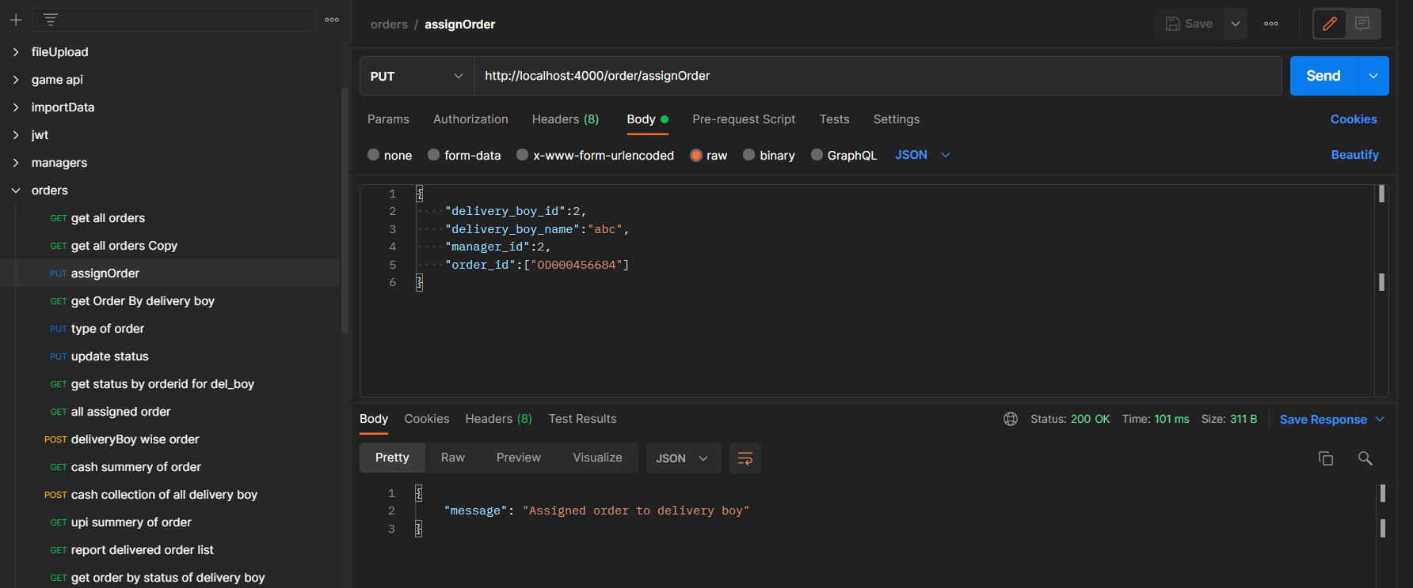

Fig 6.3.7 Manager assign order

* Delivery person can view its order.

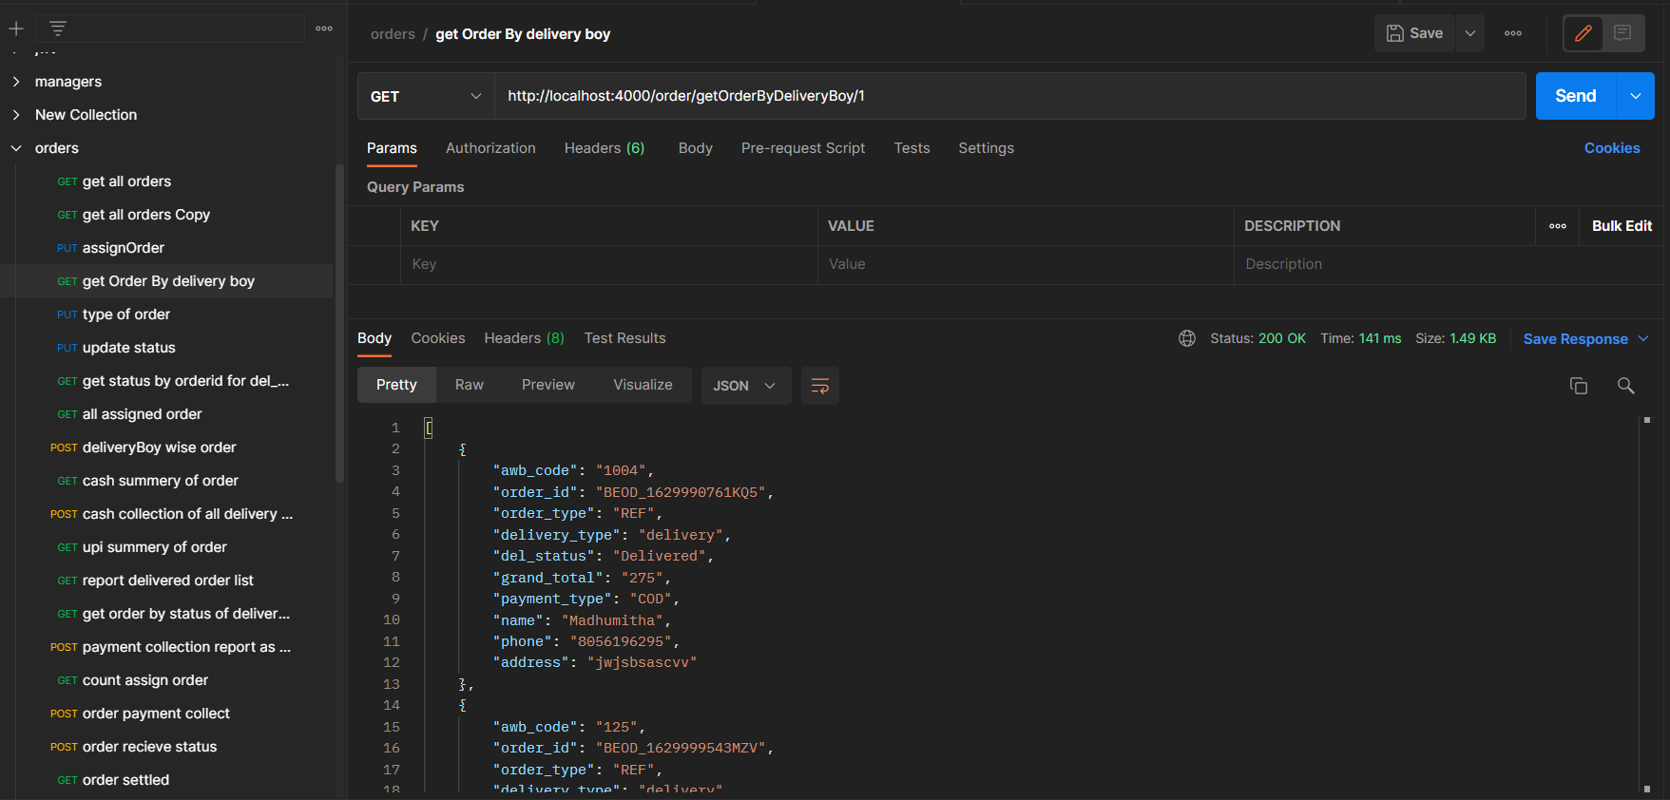

Fig 6.3.8 Order of delivery person

* Delivery person update the status of order which is delivered or cancelled.

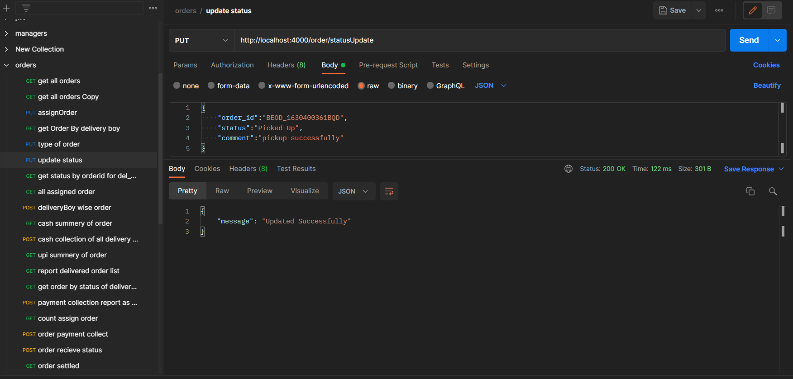

Fig 6.3.9 Update the status of Order

* Admin and Manager can view the orders of particular delivery person by datewise.

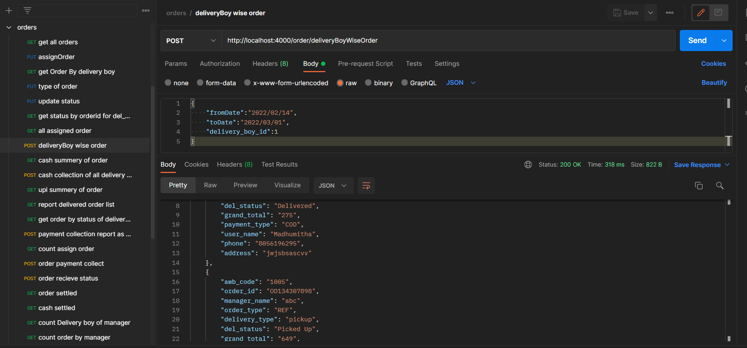

Fig 6.3.10 Delivery person wise order

* Delivery person can see the history of orders which he delivered.

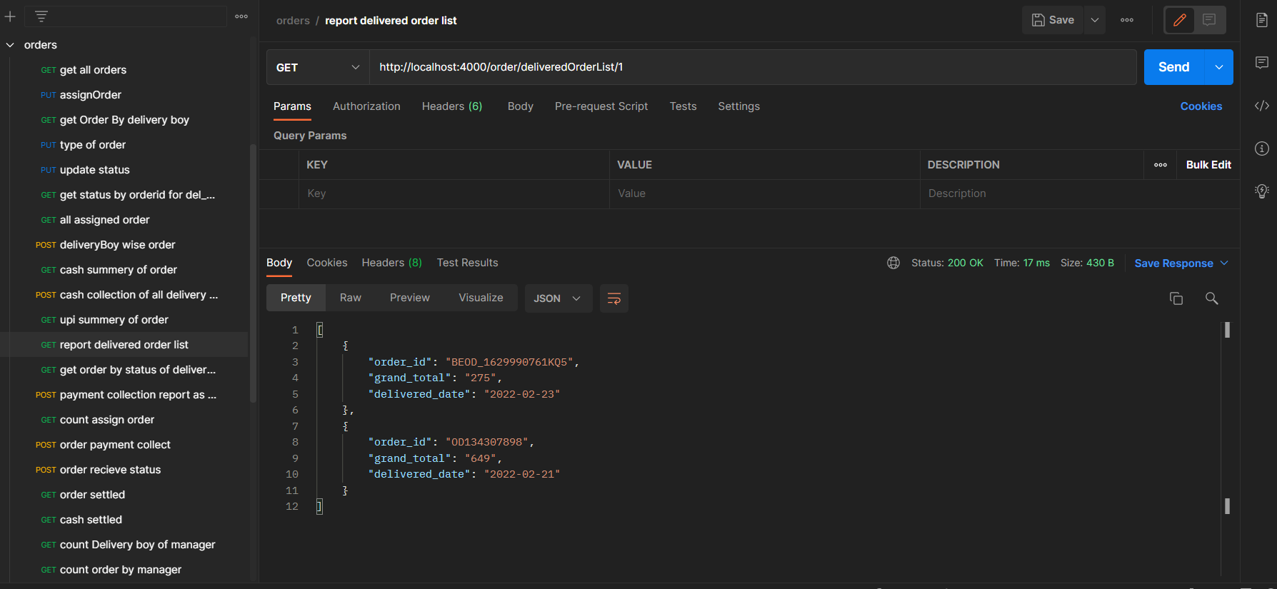

Fig 6.3.11 History of Orders for delivery person

* Admin and manager can view the cash collection report of delivery persons report.

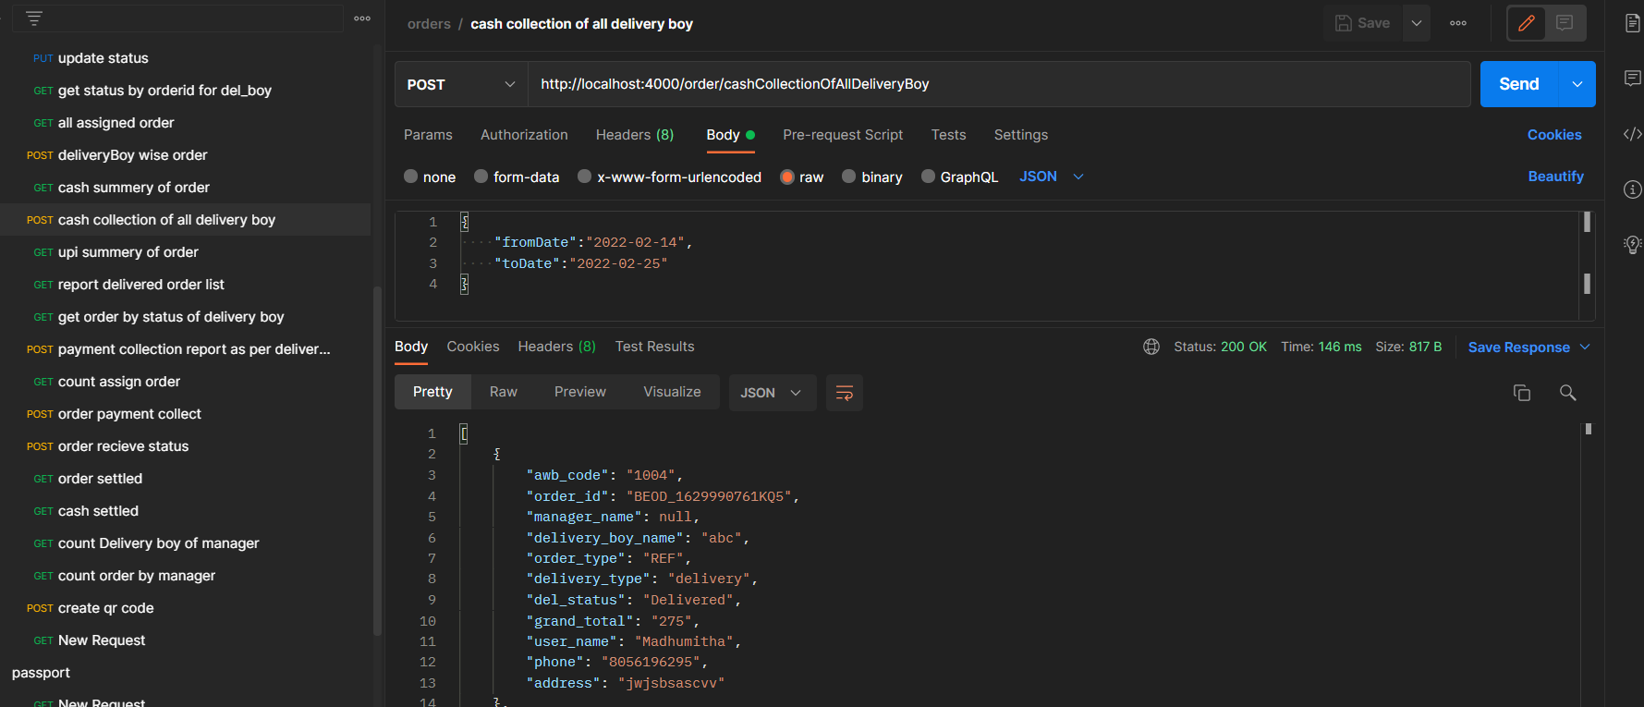

Fig 6.3.12 cash collection of delivery person

* Database

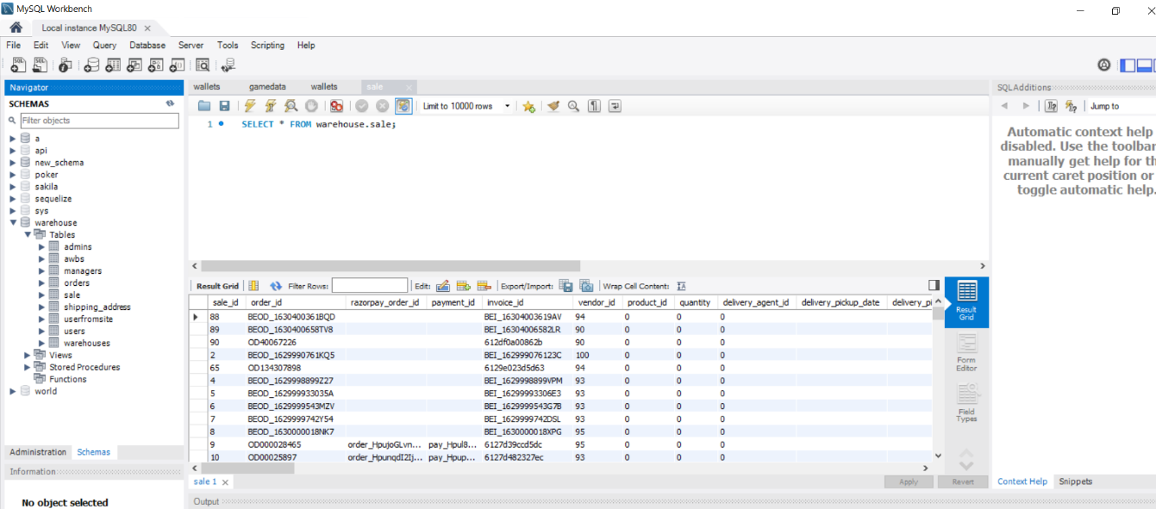

Fig 6.3.13 Database

* Manager and admin can view the reports.

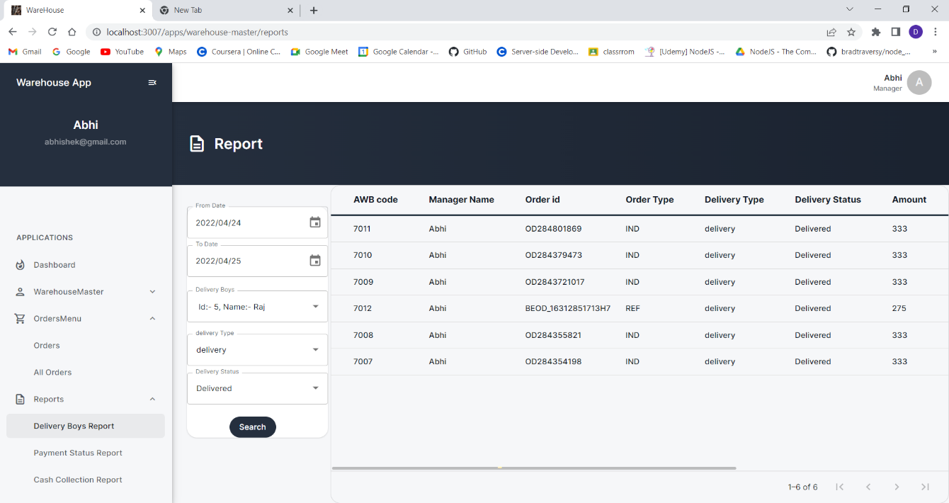

Fig 6.3.14 View the reports

* Project Code

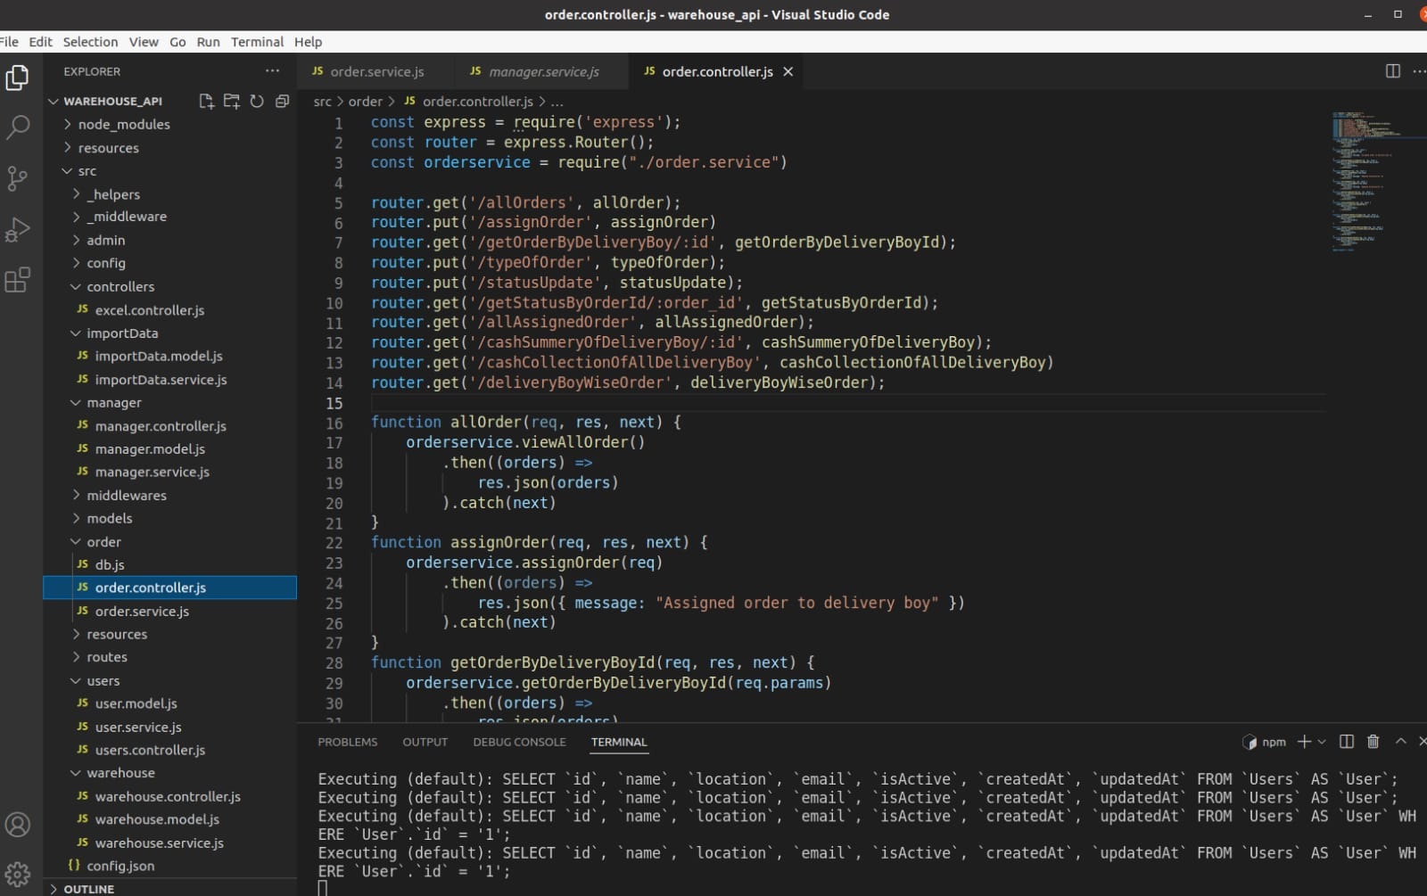

Fig 6.3.15 Project code-1

* Project Code

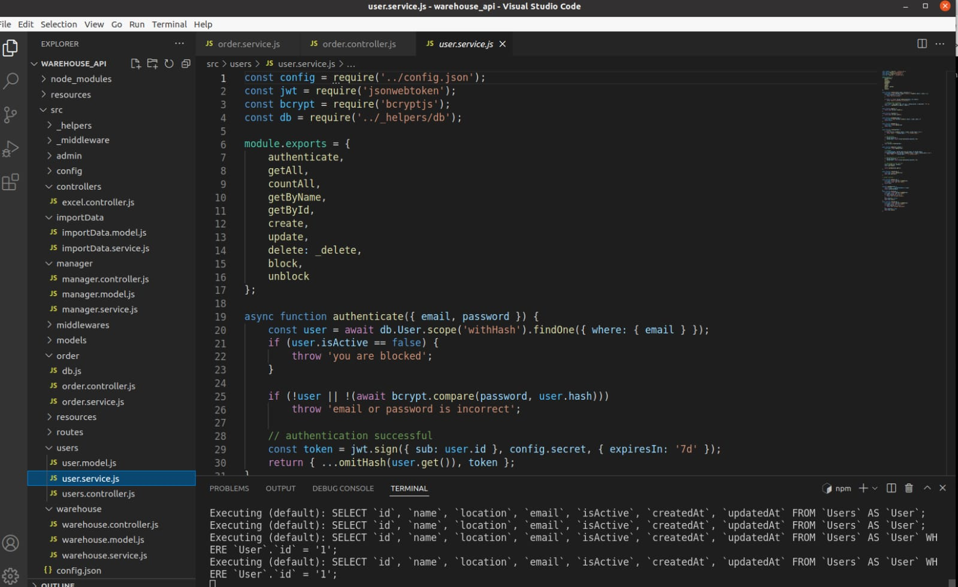

Fig 6.3.16 Project code-2

**Chapter 7: TESTING**

**7.1 TESTING PLAN**

Testing provides information about the product, and it is the first feedback to the developers. That's all. It doesn't ensure or prove anything. Testing helps people (the developers, the testers, the managers, the customers) understand what the product does and how well it does it.After Complete every module we doing testing on that module is working properly or not. The testing is important since it discovers defects/bugs before the delivery to the client, which guarantees the quality of the software. It makes the software more reliable and easy to use. Thoroughly tested software ensures reliable and high-performance software operation.

**Web Application Testing - Techniques:**

**1. Functionality Testing** - The below are some of the checks that are performed but not limited to the below list:

* Verify there is no dead page or invalid redirects.
* First check all the validations on each field.
* Wrong inputs to perform negative testing.
* Verify the workflow of the system.
* Verify the data integrity.

**2.** **Usability testing -** To verify how the application is easy to use with.

* Test the navigation and controls.
* Content checking.
* Check for user intuition.

**3**. **Interface testing -** Performed to verify the interface and the dataflow from one system to other.

**4**. **Compatibility testing-** Compatibility testing is performed based on the context of the application.

* Browser compatibility
* Operating system compatibility
* Compatible to various devices like notebook, mobile, etc.

**5.** **Performance testing -** Performed to verify the server response time and throughput under various load conditions.

* Load testing - It is the simplest form of testing conducted to understand the behaviour of the system under a specific load. Load testing will result in measuring important business critical transactions and load on the database, application server, etc. are also monitored.
* Stress testing - It is performed to find the upper limit capacity of the system and also to determine how the system performs if the current load goes well above the expected maximum.
* Soak testing - Soak Testing also known as endurance testing, is performed to determine the system parameters under continuous expected load. During soak tests the parameters such as memory utilization is monitored to detect memory leaks or other performance issues. The main aim is to discover the system's performance under sustained use.
* Spike testing - Spike testing is performed by increasing the number of users suddenly by a very large amount and measuring the performance of the system. The main aim is to determine whether the system will be able to sustain the work load.

**6.** **Security testing -** Performed to verify if the application is secured on web as data theft and unauthorized access are more common issues and below are some of the techniques to verify the security level of the system.

**7.2 TEST RESULT AND ANALYSIS**

**7.2.1 Test Case-1**

* Testing when admin Create Manager all Fields required warning message is working or not. Enter all the Required Fill details are entered correctly or not. If Admin enters wrong details then the shows message to fields all required details.

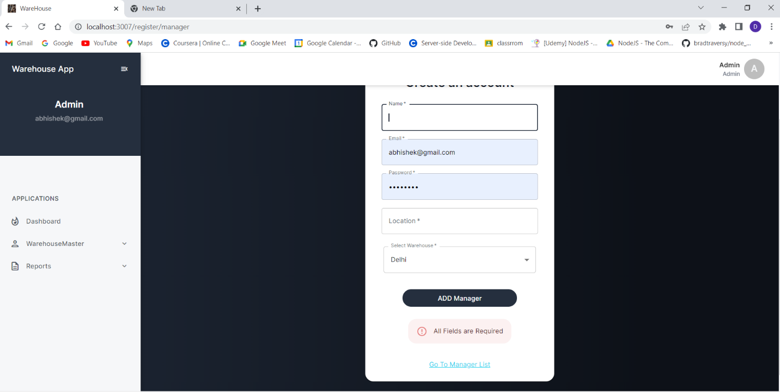

Fig 7.2.1.1 Test case-1

**7.2.2 Test Case-2**

* Testing when admin create or edit the manager or delivery person and entered the duplicate email address which already taken then the showa the message email already taken.

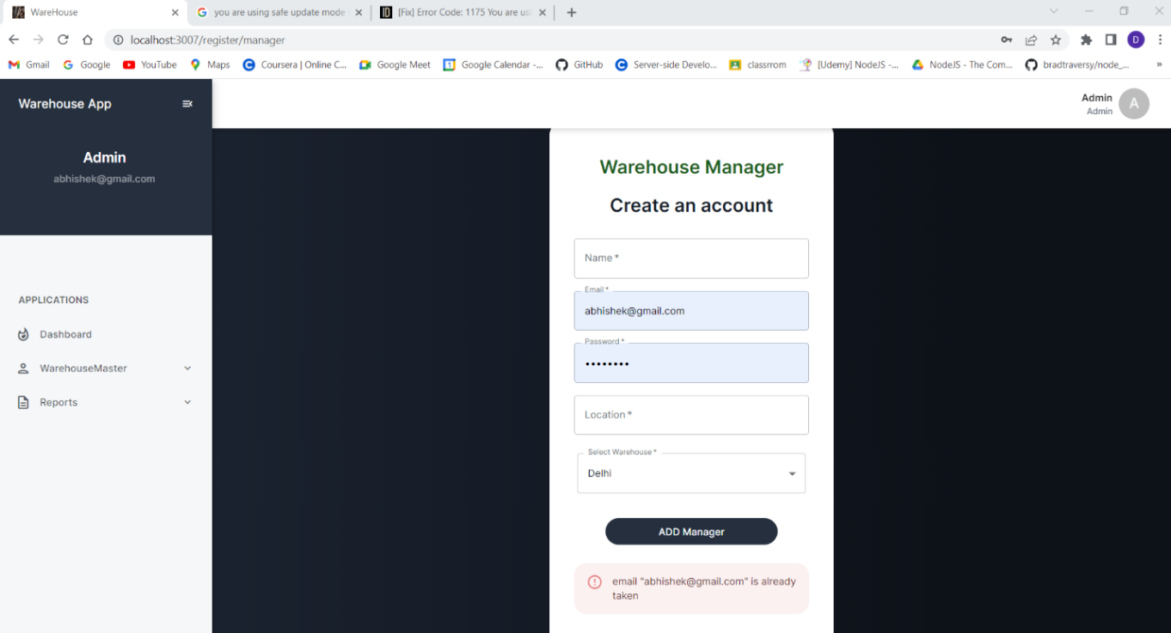

Fig 7.2.2.1 Test case-2

**7.2.3 Test Case-3**

* When Manager upload excel sheet if that contains the duplicate awb number than shows the message upload unique data.

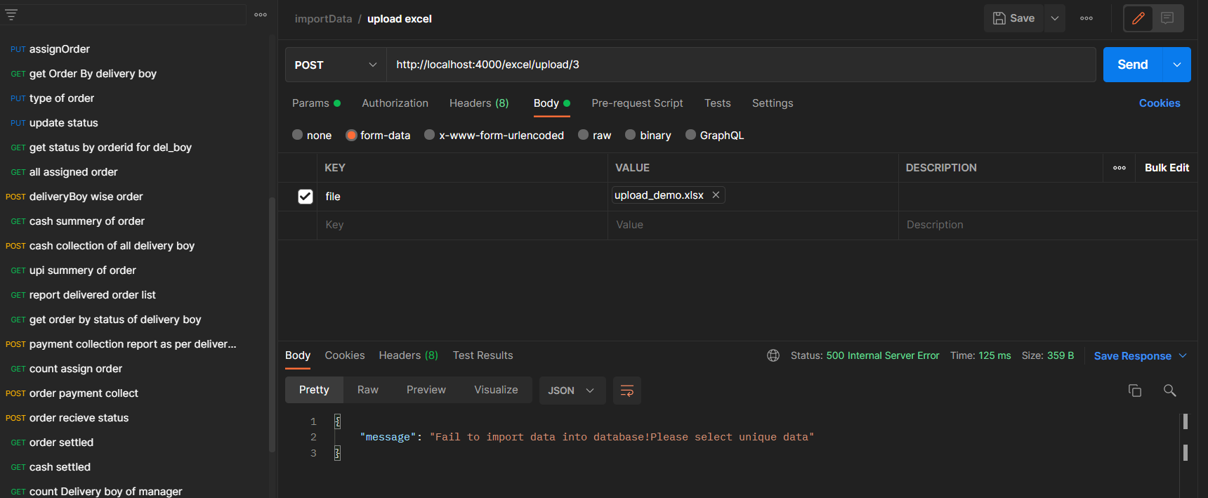

Fig 7.2.3.1 Test case-4

**CHAPTER - 8 CONCLUSION AND DISCUSSION**

**8.1 OVERALL ANALYSIS OF INTERNSHIP**

During this internship I have learned Back-End development Framework Nodejs and the How MySQL Database Work in Nodejs . I have learned about clean coding standards and clean architecture of the code. I have also learned so many soft skills like better communication and management of work.

**8.2 Date of Surprise visit by institute mentor**

* Visit 1: 17/02/2022
* Visit 2: 21/03/2022

**8.3 DATES OF CONTINUOUS EVALUATION**

* Continuous Evaluation 1: 17/02/2022
* Continuous Evaluation 2: 21/03/2022

**8.4 PROBLEMS ENCOUNTERED AND POSSIBLE SOLUTIONS**

The problem encountered in this system was to how to upload the excel file and validate that file. For that I took the help of senior developer and he help me to find the module for this problem and get the solutions.

**8.5 SUMMARY OF INTERNSHIP**

To experience the practical working of what we studied in the book theories, is very interesting, memorable and very important in our education. Doing internship is my first experience of working for any company and learn how the things are being done in the actual industry.

This internship has been an excellent and rewarding experience. During this internship I Learn about the how the projects being develop in the actual industry Also know about the company works and deals with the big clients.

**8.6 LIMITATION AND FUTURE ENHANCEMENT**

Warehouse management system used for the delivery of orders of the large ecommerce application.

In Future learn about the different different socket related library which is used into the back-end development of game.

**REFERENCES**

[1] NodeJS:

<https://www.udemy.com/course/the-complete-nodejs-developer-course-> 2/learn/lecture/13729518#overview

[Accessed: 05-Jan-2022]

[2] JWT Token Implementation:

<https://www.section.io/engineering-education/how-to-build-authentication-api-with-jwt-token-in-nodejs/>

[Accessed: 26-Jan-2022]

[3] Sequelize ORM:

https://sequelize.org/docs/v6/

[Accessed: 28-Jan-2022]

[4] Upload and download excel file in NodeJS:

<https://www.bezkoder.com/node-js-upload-excel-file-database/>

[Accessed: 10-Feb-2022]